Step 1: Prepare Item(s)
- Lift the scanner’s lid.
- Pick up the Item by the edges, taking care not to leave fingerprints.
- Place the Item face down in the upper right-hand corner of the scanning bed.
- Close the scanner’s lid.

Step 2: Open IrfanView software
- Make sure that the scanner is turned on and connected to the laptop computer.
- Open the IrfanView software from your laptop computer.

Step 3: Prepare settings
- In IrfanView, click “File.”
- From the dropdown menu click “Select Scan/TWAIN Source.”
- Select your EPSON scanner from the “Select Source” popup menu.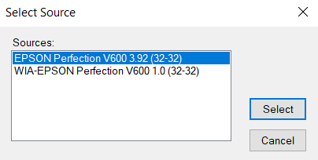
- Click “File” again.

- From the dropdown menu click “Acquire/Batch scanning” and select the following settings, then click “OK.”
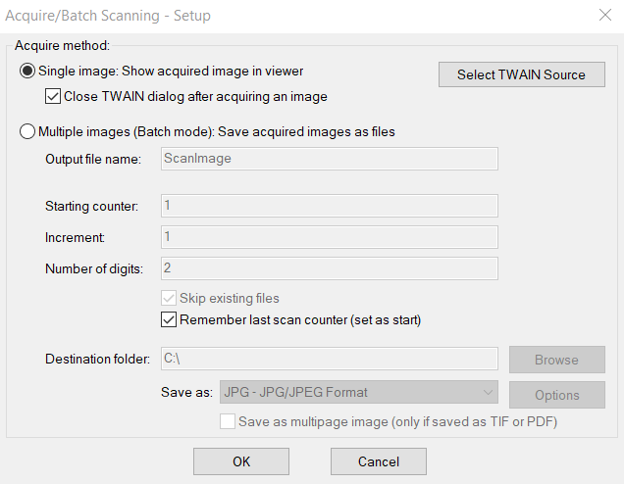

- After clicking “OK” in the previous menu, the EPSON Scan menu should appear. Under “Mode” in the upper right hand corner, select “Professional Mode.”
- Select the following settings (and see the next page for a screenshot of the scanner software settings):
  - Document Type: Reflective
  - Document Source: Document Table
  - Auto Exposure Type: Photo
  - Image Type: 24-bit Color
  - Resolution: 600 dpi
  - Leave all settings under “Adjustments” unchecked.

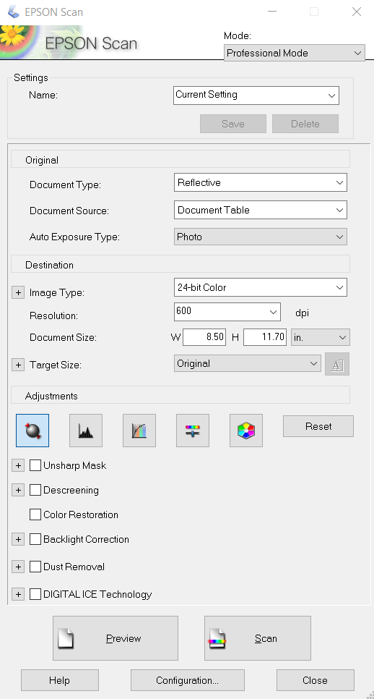

Step 4: Preview and scan photograph
- Click the “Preview” button.
- If the scanning software automatically selects the image, do not crop or rotate the image. If the software does not select the image, select the image using your mouse, leaving some white space around the image.
- After ensuring that the image preview looks correct, click the “Scan” button.
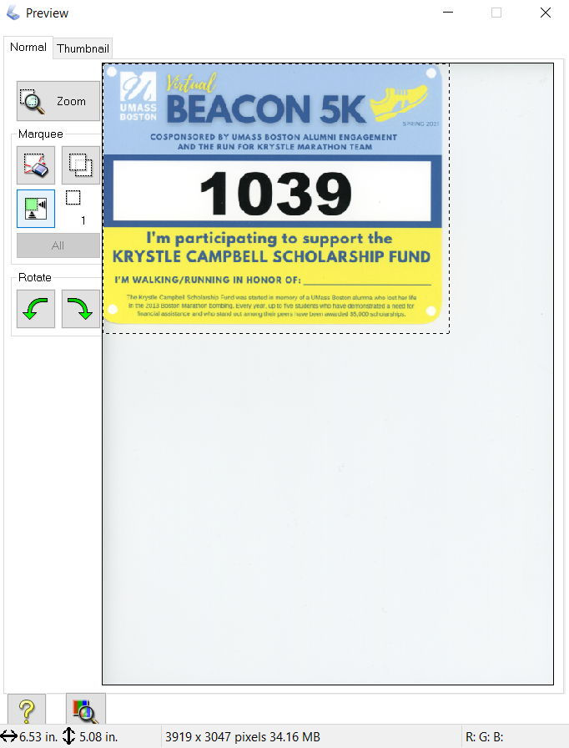

Step 5: Save file
- Click “File,” then “Save as.”
- Select the destination folder where you will save your image.
  - After saving something to the assigned event folder, the Irfanview software should default to saving future items to that same folder.
- In the “File name” box, enter the Item ID Number from the corresponding Descriptive Information Form (e.g. 75-97-2).
  - If there are multiple pages of an Item, rename each page of the file with a letter after the Item ID Number. (e.g. 75-97-2a, 75-97-2b, 75-97-2c, etc.)
- In the “Save as type” box, select “TIF - Tagged Image File Format.”
- Click “Save.”

Step 6: Notate and store paperwork
- After scanning the Item, note that the Item was scanned at 600 dpi in the “For Project Team Use Only” section of the Descriptive Information Form.
- Store the completed Descriptive Information Form in the provided document envelope.

Step 7: Finished!
- Return the Item to the Contributor.

Note: Under no circumstances should you rotate, crop, or otherwise edit an image or Item file after it's been saved. All image editing and processing will be carried out by the Digital Preservation Specialist.

