It is imperative to assign a unique Item ID Number to each Item you want to add to your new collection. The Item ID Number is used to link digital files to individual Contributors and their descriptions about those Items. When a Contributor visits each of the event stations in order, their Item ID Numbers will be assigned as part of the Numbering System.

The Numbering System assigns every Item in the collection a unique Item ID Number consisting of three parts: a pre-assigned event number, followed by the Contributor’s event registration or nametag number, followed by the number of that particular item that the Descriptive Information Form describes (1, 2, 3, etc.).

AT THE WELCOME STATION

The Event Number
The first section of the Item ID Number identifies the event number. Your Project Team may decide to host more than one event, and an event number is a way to differentiate between these events. If this is your first event, the number will be 1. If this is your second event, the number will be 2, and so on.
You can pre-fill this section of the Event Registration and Permission Form since all the forms will be used at the same event. If this is a one-time event, your Project Team may decide to remove this section from the form.

The Contributor Number
The middle section of the Item ID Number is the Contributor’s unique identifier number. When Contributors arrive at the Welcome Station, they will be given a pre-numbered nametag with a unique registration number. The Welcome Station Volunteers will help the Contributor record this Contributor Nametag Number in the top section of the Event Registration and Permission Form.

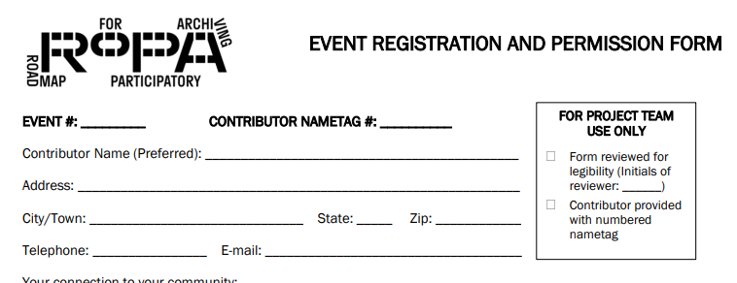

It is important that the Contributor display their nametag somewhere visible at all times while they are at the event. The pre-numbered nametags are the only way to ensure that Contributors have completed the Event Registration and Permission Form and that their Items are identified as their own. When Contributors move from the Welcome Station to the other stations, Volunteers at those stations will need to verify their Contributor number by looking at their nametag.

AT THE INFORMATION STATION

When the Contributor arrives at the Information Station, the Information Station Volunteers will help the Contributor complete the Item ID Number section at the top of the Descriptive Information Form. Each Item requires a separate Descriptive Information Form with a unique Item ID Number.

The first line of the Item ID Number is for the event number. You can pre-fill this section of the Descriptive Information Form since all the forms will be used at the same event. If this is a one-time event, your Project Team may decide to remove this section from the form.

The second line is for the Contributor number. This is the number on the Contributor’s nametag.

The Item Number
The final section of the Item ID Number is the number of the specific Item from the Contributor’s set of Items. A Contributor’s first Item is designated number 1, the second Item is number 2, and so on. Your Project Team may choose to limit the number of Items from a Contributor or allow an unlimited amount of contributions.

Before the Contributor can move onto the Copying Station, an Information Station Volunteer will review the Descriptive Information Form and initial the For Project Team Use Only section of the form to verify legibility and completeness of the form, including the Item ID Number.

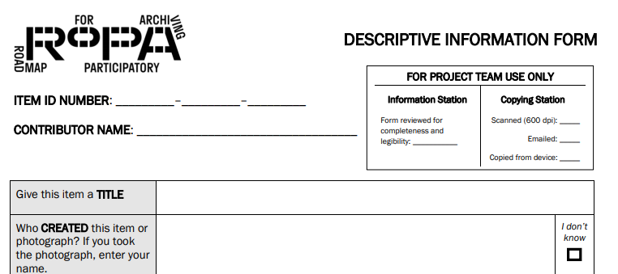

AT THE COPYING STATION

When the Contributor arrives at the Copying Station, they will bring their Items and a completed Descriptive Information Form for each Item. The Copying Station Volunteers will use the completed Item ID Number from the form to name the digital file of the Item when they save the files.

When a Contributor brings a completed Descriptive Information Form to the Copying Station, along with the materials that are being copied, the Copying Station Volunteer will be able to confirm that the Contributor has already registered for the event and will be able to save the Contributions with the appropriate file name to match both the Event Registration and Permission Form and the Descriptive Information Form.

