Sample Event Registration and Permission Form
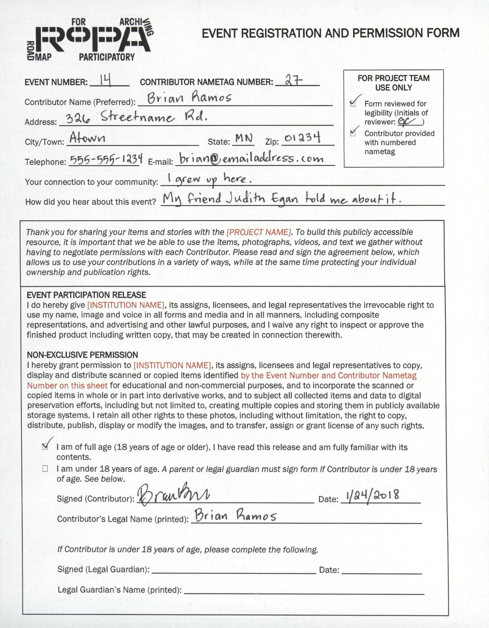

Section of Spreadsheet | Section to use from Form | Content from Sample Form
Event Number | Use full EVENT NUMBER provided on form. | 14
Contributor Nametag Number | Use full CONTRIBUTOR NAMETAG NUMBER provided on form. | 27
Contributor's Name (Preferred) | Use the Contributor's name, as entered in the "Contributor Name (Preferred)" section of the form. Enter as "[Last Name], [First Name] [Middle Name/Initial], [Suffix]” | Ramos, Brian
Contributor's Legal Name (Last Name) | Use the Contributor's last name, as entered in the "Contributor’s Legal Name (printed)" section of the form. | Ramos
Contributor's Legal Name (First Name) | Use the Contributor's first name, as entered in the "Contributor’s Legal Name (printed)" section of the form. | Brian
Contributor's Legal Name (Middle Name or Middle Initial, if any) | Use the Contributor's middle name or middle initial, as entered in the "Contributor’s Legal Name (printed)" section of the form. If the Contributor didn't provide a middle name or middle initial, leave this section of the spreadsheet blank.
Contributor's Legal Name (Suffix, such as "Jr." or "III") | OPTIONAL.  Use the Contributor's first name, as entered in the "Contributor’s Legal Name (printed)" section of the form. If the Contributor didn't provide a suffix (such as "Jr." or "III"), leave this section of the spreadsheet blank.
Contributor Address | Use the Contributor's street address, as entered in the "Address" section of the form. | 326 Streetname Rd.
Contributor City/Town | Use the city or town where the Contributor lives, as entered in the "City/Town" section of the form. | Atown
Contributor State | Use the state where the Contributor lives, as entered in the "State" section of the form. | MN
Contributor Zip | Use the location zip code for where the Contributor lives, as entered in the "Zip" section of the form. | 01234
Contributor Telephone | Use the Contributor's telephone number, as entered in the "Telephone" section of the form. | 555-555-1234
Contributor  E-mail | Use the Contributor's e-mail address, as entered in the "E-mail" section of the form. | brian@emailaddress.com
Contributor response to question: "Your connection to your community" | OPTIONAL.  Use the information that the Contributor entered into the "Your connection to your community" section of the form. If the Contributor didn't enter anything into this section of the form, leave this section of the spreadsheet blank. | I grew up her.
Contributor response to question: "How did you hear about this event?" | OPTIONAL.  Use the information that the Contributor entered into the "How did you hear about this event?" section of the form. If the Contributor didn't enter anything into this section of the form, leave this section of the spreadsheet blank. | My friend Judith Egan told me about it.
Did Contributor sign and date the form? (Yes or No) | If the Contributor signed and dated the form, enter "Yes" in this section of the spreadsheet. If they did not, enter "No." | Yes
Is Contributor 18 years of age or older? (Yes or No) | Enter "Yes" if the Contributor checked the box noting that: "I am of full age (18 years of age or older). I have read this release and am fully familiar with its contents." Enter "No" if the Contributor checked the box noting that "I am under 18 years of age." | Yes
If the Contributor is not 18 years of age or older, did their Parent or Legal Guardian also sign the form? | If the Contributor is not 18 years of age or older, their Parent or Legal Guardian must also sign the form. If this is the case, did a Parent or Legal Guardian sign the form in the "Signed (Legal Guardian)" section of the form? Enter "Yes" or "No." If the Contributor is 18 years of age or older, enter "N/R" (Not Relevant) in the section of the spreadsheet. | N/R
If the Contributor is not 18 years of age or older and their Parent or Legal Guardian signed the form, enter the Parent or Legal Guardian's name. | If relevant, enter the Parent or Legal Guardian's name as it appears in the "Legal Guardian’s Name (printed)" section of the form. If possible, enter as "[Last Name], [First Name] [Middle Name/Initial], [Suffix]"

