Sample Descriptive Information Form
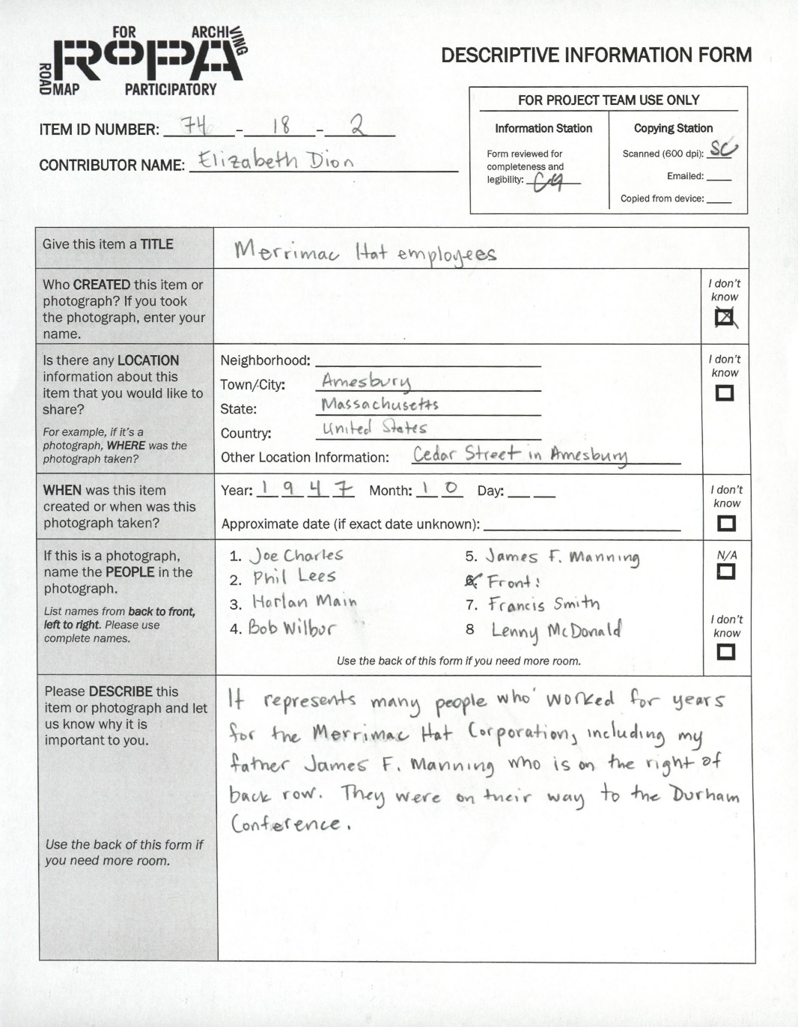
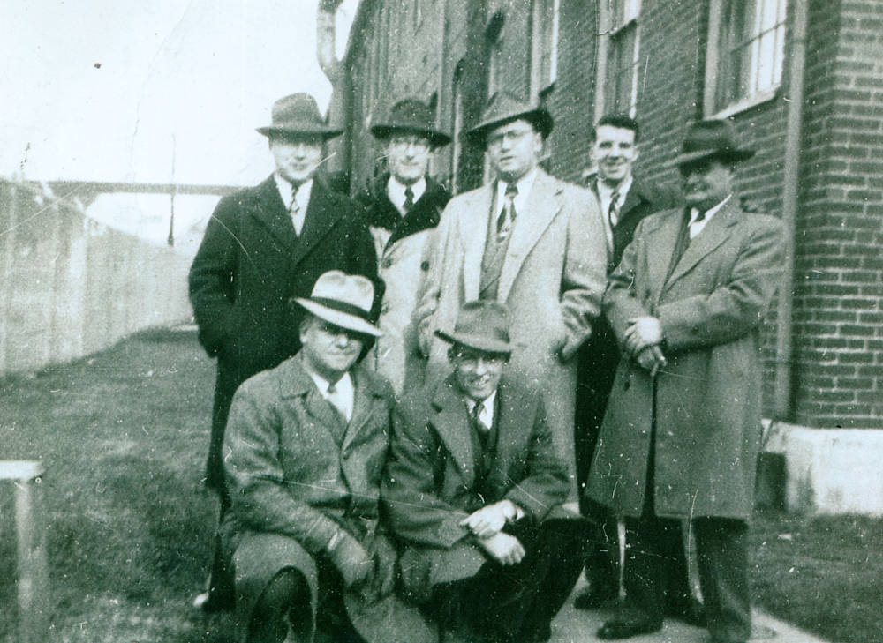

Above: Photograph contributed by Elizabeth Dion to the Amesbury Mass. Memories Road Show participatory archiving event.

At left: RoPA Descriptive Information Form containing the information that Elizabeth Dion provided about her photograph.

Section of Spreadsheet | Section to use from Form | Content from Sample Form
Identifier | REQUIRED.  Use full ITEM ID NUMBER provided the Form. | 74-18-2
Title | REQUIRED.  Use information from "TITLE" section of Form. | Merrimac Hat employees
Creator | REQUIRED, IF INFORMATION IS AVAILABLE.  Use name in "Who CREATED this item or photograph?" section (if a name is provided) of Form. Enter personal names in the following format: "[Last Name], [First Name] [Middle Name/Initial], [Suffix]”. If the name also has a suffix, like “Sr.” or “Jr.” include the information at the end of the name, preceded by a comma. For example, if the Creator's name is "Alexander J. Smith, Jr." you would enter that name here as "Smith, Alexander J., Jr." | [The Contributor didn’t provide any information about the Creator of this Item, so leave this section blank]
Contributor | REQUIRED.  Use information listed in the CONTRIBUTOR NAME section of the Form. Enter names in the following format: "[Last Name], [First Name] [Middle Name/Initial], [Suffix]”. If the name also has a suffix, like “Sr.” or “Jr.” include the information at the end of the name, preceded by a comma. For example, if the Creator's name is "Anthony K. Silva, III" you would enter that name here as "Silva, Anthony K., III" | Dion, Elizabeth
Date (Actual) | REQUIRED, IF INFORMATION IS AVAILABLE.  Use information listed in "WHEN was this item created or when was this photograph taken?" section of the Form. If no date is provided or if the date is noted as Approximate, do not enter this information in this Date (Actual) field, but rather in the "Date (Estimated)" field of this spreadsheet. The date should be entered in the following format: YYYY-MM-DD, which matches the way the date would be entered on the Descriptive Information Form. You may include just a year (YYYY), a year and a month (YYYY-MM), or a a year and a month and a day (YYYY-MM-DD). | 1947-10
Date (Estimated) | OPTIONAL.  Use information listed in "WHEN was this item created or when was this photograph taken?" section of the Form. Only enter date information in this field if no date is provided or if the date is noted as Approximate. If the date is approximate, precede the date information with "circa". For example, if the Form reads "around April 1984" enter the information as "circa April 1985." If no date is provided (or if the "I don't know" box is checked) enter "Date unknown". | [The actual date is known, so leave section blank]
Geographic Subject | OPTIONAL, REQUIRES RESEARCH.  To complete this section, use information and locations listed in the "Is there any LOCATION information about this item that you would like to share?" section of the Descriptive Information Form. The Online Access Specialist should investigate how your digital repository will display this information. One resource to guide your data entry could by the Getty Thesaurus of Geographic Names® Online: http://www.getty.edu/research/tools/vocabularies/tgn/index.html | Optional/requires research. The use of this section will also depend on how your online access digital repository displays this kind of information.
Personal Name Subject | Use information listed in the "If this is a photograph, name the PEOPLE in the photograph." section of Form. Enter names in the following format: "[Last Name], [First Name] [Middle Name/Initial], [Suffix]”. Separate multiple names with a semicolon (e.g. Whistle, Sarah; Vasquez, Isabela; Chalke, George). Only include full names -- you'll have the opportunity to include partial names (and names of pets and such) in the Description section on the spreadsheet. | Charles, Joe; Lees, Phil; Main, Harlan; Wilbur, Bob; Manning, James F.; Smith, Francis; McDonald, Lenny
Description | Use information from 3 different sections of the Form to create a Description for the Item. Include this information within single quotation marks, to help show that the information was provided by someone else (the Contributor). See sample entry for a visual example.  First, transcribe the information provided in the "Please DESCRIBE this item or photograph and let us know why it is important to you." section of the Form.  Second, list the people and names identified in the "If this is a photograph, name the PEOPLE in the photograph." section. Precede your entry of this information with "Pictured:" or "Pictured (back to front, left to right):" See sample entry for more information.  Third, enter the information (if any) provided by the Contributor in the "Other Location Information:" area of the "Is there any LOCATION information about this item that you would like to share?" section of the Form. Precede your entry of this information with "Location:" See example entry for more information. | 'It represents many people who worked for years for the Merrimac Hat Corporation, including my father James F. Manning who is on the right of back row. They were on their way to the Durham Conference. Pictured, from back to front, left to right: Joe Charles, Phil Lees, Harlan Main, Bob Wilbur, James F. Manning, (front) Francis Smith, Lenny McDonald. Location: Cedar Street.'
Language | OPTIONAL.  What language did the Contributor use to describe of this Item? OPTIONAL. | English
Source | OPTIONAL.  What's the name of your participatory archiving event? Enter it here. | Amesbury Mass. Memories Road Show
Relation | OPTIONAL.  Is there a URL for this collection? Enter it here. You may not have a URL for this collection until it’s posted online, so you may need to leave this section of the spreadsheet blank at first. | https://openarchives.umb.edu/digital/collection/p15774coll6/search/searchterm/Amesbury%20Mass.%20Memories%20Road%20Show/field/roada/mode/exact/conn/and
Type | OPTIONAL. TO BE COMPLETED BY THE ONLINE ACCESS SPECIALIST.  This section uses the Dublin Core Metadata Initiative (DCMI) Type Vocabulary, which includes the following "type" options: Collection, Dataset, Event, Image, Interactive Resource, Moving Image, Physical Object, Service, Software, Sound, Still Image, Text  Note: Most Items contributed at your event and digitized will be labeled either "Still Image" or "Text" -- for a fuller overview of each "Type" visit https://www.dublincore.org/specifications/dublin-core/dcmi-type-vocabulary/. | Still Image
Format | OPTIONAL. TO BE COMPLETED BY THE ONLINE ACCESS SPECIALIST.  What is the file format for the digital file associated with this Item? Use the Internet Media Types controlled vocabulary (https://www.iana.org/assignments/media-types/media-types.xhtml). The following media types are the most common with participatory archiving events like those described in RoPA: application/pdf, image/jpeg, image/jp2, image/tiff.  Note: Because of digital preservation processing and standardization carried out in the Preserving the Collection module of RoPA, most or all of the Formats for files will be either "image/tiff" or "application/pdf". | image/tiff
Rights | REQUIRED.  Enter the Rights Statement your Project Team developed for this Participatory Archiving project, including information about take-downs, etc. | Copyright restrictions may apply. Visit blogs.umb.edu/archives/about/rights-and-reproductions for more information and to review our takedown policy.
File Name | REQUIRED.  If you have followed the instructions in RoPA, the file name for each Item should match the Identifier for each Item. Depending on your digital repository platform, you might need to include the file extension (for example, .tiff or .pdf or .jpg) for the files to upload properly. | 74-18-2.tif

